**1️⃣ Account Transaction Flow**

**Account** represents a place where money is stored: Cash, Bank, Wallet, etc.

**Flow:**

1. **Create Account:**
   * User adds an account with an **opening balance**.
   * Current balance is initialized to opening balance.
2. **Transactions:**
   * Every Expense, Liability, or Loan affects one or more accounts.
   * Example:
     + Expense paid from Bank account → Current balance decreases.
     + Loan received into Cash account → Current balance increases.
3. **Update/Delete:**
   * Account balance should be updated automatically when transactions occur.
   * Deleting an account requires handling existing transactions (archive or restrict deletion).

**Entities Involved:** Account, Transaction (optional table to track history).

**2️⃣ Expense Transaction Flow**

**Expense** represents money going out for goods or services.

**Flow:**

1. **Create Expense:**
   * User chooses **account** to pay from.
   * Enter **expense amount** and **category/type** (e.g., Rent, Utility).
2. **Update Account Balance:**
   * Account current balance is reduced by the expense amount.
3. **Optional Linking:**
   * Expense may be linked to a project, department, or user for reporting.
4. **Delete Expense:**
   * Deleting an expense may **refund the account balance** (optional based on business logic).

**Entities Involved:** Expense, Account, Transaction (for history/logging).

**3️⃣ Liability Transaction Flow**

**Liability** represents obligations to pay in future (Credit Card, Bills, Payables).

**Flow:**

1. **Create Liability:**
   * User adds a new liability with **amount**, **due date**, and **type**.
   * No immediate effect on account balance until paid.
2. **Payment of Liability:**
   * Choose account to pay from.
   * Reduce the account current balance by the paid amount.
   * Mark liability as **Paid/Partial/Outstanding**.
3. **Reporting:**
   * Track total liabilities, outstanding amount, due soon, overdue.

**Entities Involved:** Liability, Account, Transaction (for payment history).

**4️⃣ Loan Transaction Flow**

**Loan** represents borrowed or lent money.

**Flow:**

1. **Create Loan:**
   * User records **loan amount**, **type** (Personal, Business), **status** (Active, Paid), **due date**.
   * If it’s **incoming money** (loan received), account balance increases.
   * If it’s **outgoing loan** (loan given), no immediate effect on account unless money is transferred.
2. **Repayment / Receipt:**
   * Payment reduces account balance if paying a loan.
   * Payment received increases account balance if collecting a loan.
   * Update loan status (Partial, Paid).
3. **Reporting:**
   * Outstanding loan amount, due soon, overdue.
   * Aggregate by type.

**Entities Involved:** Loan, Account, Transaction (loan payments).

**5️⃣ Common Transaction Mechanism**

For **all entities**, it’s good to have a **central Transaction table**:

| **Field** | **Description** |
| --- | --- |
| id | Transaction ID |
| account | Linked account |
| type | Credit/Debit |
| entityType | Expense / Liability / Loan / Other |
| entityId | ID of the linked entity |
| amount | Amount of transaction |
| date | Timestamp |
| description | Optional note |

**Advantages:**

* Track all account movements.
* Generate reports per account, type, or time range.
* Ensure integrity of balances.

✅ **Summary:**

* **Account:** Central point; balance affected by all transactions.
* **Expense:** Money going out → reduce account balance.
* **Liability:** Future obligation → reduce balance on payment.
* **Loan:** Money lent or received → adjust account on payment/receipt.
* **Transaction table:** Unified history to maintain integrity.

If you want, I can **draw a clear diagram showing the flow of money between these 4 entities**, which will make it very easy to implement.

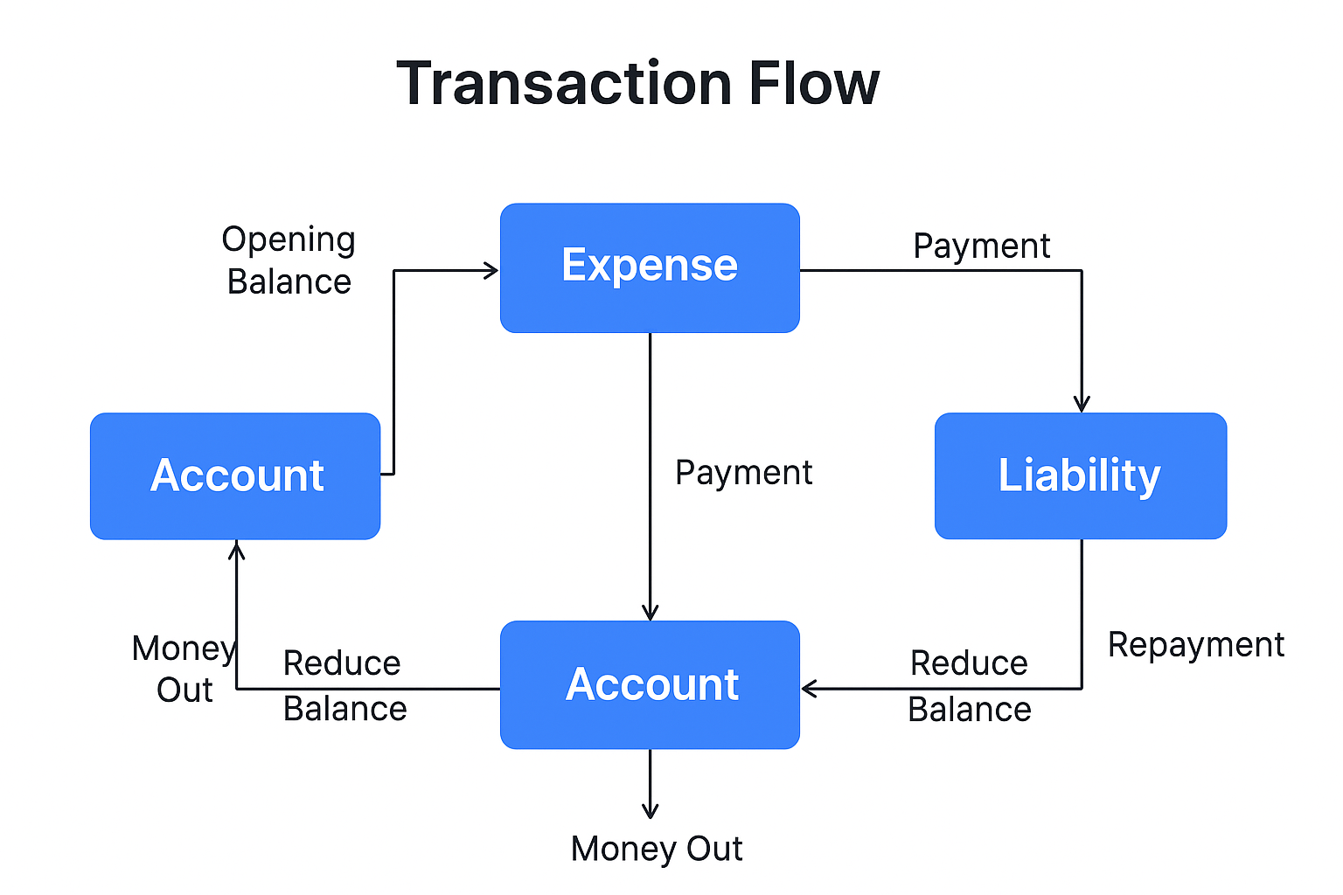

Based on the provided Software Requirement Specification (SRS), **four (4) distinct reports** should be implemented:

1. **Expense Report:** Shows total expenses by category for a given date range.
2. **Cash Flow Report:** Shows inflows vs. outflows per account.
3. **Liability Report:** Shows pending (unpaid) liabilities.
4. **Loan Report:** Shows outstanding loan balances.